
event safety management plan
THE SCOTTISH SCHOOLS PIPE BAND CHAMPIONSHIPS

SUNDAY 8th MARCH 2026


Event Safety Management Plan

Contents
Section 1: Task Statement 2
Section 2: Event Outline 2
Section 3: Plan, Aims and Objectives and Site Environment 2
Section 4: Event Management Structure 4
Section 5: Emergency Procedures and Wind Management 5
Section 6: Evacuation Procedures 6
Section 7: Event Cancellation 6
Section 8: Fist Aid - to be used 6
Section 9: Alcohol Management 5
Section 10: Capacity 7
Section 11: Fire Precautions and Equipment 9
Section 12: Communications and Programme 10
Section 13: Waste Management 10
Section 14: Toilets- 10
Section 15: Noise Management Policy 11
Section 16: Catering Requirements (Food, drink, water) 11
Section 17: Lost Children 12
Appendix 1 – Location Plan and Site Layout Plan 0
Appendix 2 – Risk Assessments 2

Section 1: Task Statement

This Safety Management Plan outlines the procedures and responsibilities for the Scottish Schools Pipe Band Championships Committee, in accordance with the “The Event Safety Guide: The Purple Guide to Health and Safety and Welfare at Music and Other Events”
It details the immediate response protocols by the Schools Schools Pipe Band Steering Group for any incident that may impact spectator safety or disrupt event operations. The event will be held at William McIlvanney Campus Kilmarnock, or Sunday 8th March, 2026.
The plan also considers the operational needs of the Emergency Services should they be required to attend.

Section 2: Event Outline

The Scottish Schools Pipe Band Championships is the world’s largest schools piping competition, held annually on the second Sunday in March. The one day event is held indoors and welcomes schools from across the UK with competitors from beginners to elite performers, featuring in pipe bands, quartets, and freestyle groups.
Event duration: 9.00 am to 5.30 pm
Set-up Time: begins at 7.00 am, with arrival from 8 am.
Media Promotion: pre-event advertising via media channels.
Estimated Attendance: up to 2,000 people (not all present simultaneously). This has been established as the final capacity with a comparison taken from;
- Fitness Suite: 115.82 m²
- Dance Studio: 214.48 m²
- Gym Hall 1: 647.03 m²
- Gym Hall 2: 496.99 m²
- Primary School Gym Hall: 335.48 m²

Parking & Transport
- Main car park: 160 spaces (7 Disabled spaces)
- Leisure carpark: 56 spaces (5 Disabled spaces)
- Coach Drop-off: Manned with signage and supervision

Safety Objectives
- Ensure the safety and security of all attendees
- Respond immediately to any safety risks
- Maintain public order and manage evacuation if necessary
- Support and coordinate with emergency services
.
Operational Measures
- Stewards assigned to each school to assist throughout the day.
- Over 90 performances scheduled
- Stewards to manage performance flow and audience comfort
- Regular breaks and lunch provided for stewards
- Control measures implemented and monitored for effectiveness.

Section 3: Plan, Aims and Objectives and Site Environment

The Safety Management Plan aims to provide a comprehensive event document in ensure all staff involved in the event clearly understand their roles and how these roles interact with other contributors.
Objectives
- Deliver a successful, safe, and enjoyable event experience
- Anticipate and plan for potential problems or disruptions
- Identify trigger points for activating emergency procedures

Site Environment and Safety Measures
The Event Manager, Patrick Gascoigne, is responsible for ensuring all event staff maintain a safe working environment. Key safefy measures include:
- All areas will be arranged and equipment installed to avoid obstructing exit points.
- Equipment will be positioned to prevent unnecessary slips, trips, or falls for staff, operators, and attendees.
- The event site will be kept clean, free from litter, waste, and spillages, and will be restored to its original condition post-event
- Access to hazardous equipment areas will be restricted to authorised personnel only
- Pipe band equipment will be stored safely away from public areas or in designated storage areas as advised by the Event Manager.

Section 4: Event Management Structure

Event Manager – Patrick Gascoigne
Responsibilities:
- Ensure the safety of all staff, volunteers, and attendees.
- Coordinate all aspects of the event.
- Assign roles and responsibilities for event control on Sunday 8th March, 2026.

Safety Deputy Support (Deputy Event Manager) – David Johnston
Responsibilities
  - Assist and assume Event Manager duties if required
  - Confirm incident details and notify the Event Manager via mobile.
  - Contact emergency services and coordinate with Stewards
  - Log all incidents and brief Event Manager
  - Collect and relay information from Volunteer Stewards
  - Maintain constant surveillance of incidents
  - Coordinate evacuation procedures as instructed.
  - Confirm evacuation and await stand-down instructions

Stewards Volunteer Co-ordinator - Mr Benjamin Fyffe
Responsibilities
- Organise, support, brief, and supervise stewards in designated areas.
- Immediately respond to incidents and notify the Event Manager.
- Avoid Direct involvement in incidents.
- Ensure all incident details are logged and communicated.
- Follow Event Manger instructions and assist in evacuation procedures.
- Liaise with the Event Manager and respond to emergency messages

Scottish Pipe Band Championships Contacts
Name | Role | Contact details
Patrick Gascoigne | Event Manager | 07793 903828
David Johnston | Deputy Event Manager
Benjamin Fyffe | Steward Volunteer Support
Steve Robb | Chief Sound Technician
Jade Darby | Stage Manager

Please note the venue is clearly defined refer to Appendix Number 1 for the site plan and layout. The communications will generally be carried out verbally, with mobile phones as back-up.

Section 5: Emergency Procedures and Wind Management

Weather monitoring is key to any event as weather conditions can not only make or break an event but can also be potentially hazardous putting attendees at risk. As a result, all precautions have been taken and controls put in place to ensure that adverse weather can be managed. We being, the event organiser have been gathering information on weather conditions, either by monitoring the forecast of monitoring conditions onsite the event can be best prepared for adverse weather conditions
The Event Manager will monitor weather through conventional systems such as BBC Weather and Met Check as these forecasts can offer in-depth and accurate information.

Patrick Gascoigne, being the Event Manager, will be supported by Mr Benjamin Fyffe who will be in charge of a 20-strong team of volunteers carefully selected from the top year of senior pupils from the William McIlvanney Campus. These volunteers will receive a briefing on the Friday before the event and will be very familiar with the layout of the campus, both within and without, and also with all extant emergency safety procedures.

Section 6: Evacuation Procedures

If the Event Manager decides that a controlled evacuation of the site is required then the following procedure will apply;
- Volunteers take position
- Announcement made by loud voice.
- Everyone is advised to leave by the nearest safest exit and to locate to a Muster Point away from the hazard – a suitable area within the William McIlvanney main car park.

Section 7: Event Cancellation

The Event Manager will ultimately take responsibility for deciding if the event should not go ahead because of any adverse matter and will ensure this is communicated quickly and effectively.

Section 8: Fist Aid

Four qualified first aiders will be at the event for the full duration. The First Aid Point will be set up in a designated area within the main reception area of the William McIlvanney Campus.

Section 9: Alcohol management

No alcohol involved for this event.

Section 10: Capacity

The initial process undertaken to establish capacity is as follows:
- The overall space
- Available viewing area
- Density profile
- Potential capacity
The capacity can be defined as how many people can safely attend the event. There are several other control measures in establishing capacity that have to be considered:-
- How people get there
- Queuing times
- Means of escape
- Evacuation time
- Historical data
In calculating capacities guidance has been taken from:
- Green Guide Safety at Sports Grounds
Entry capacity of 2000 can be calculated for this event using the following calculation and taking into consideration the following conditions and assumptions.
The calculated occupant capacity of the premises, or any part thereof, should be determined:
- in areas where fixed seating is provided
  - if individual seats, by the number of such seats, and
  - if bench seats or similar continuous seating, by dividing the total width of such seating by 450 mm;
and;
- In other areas (including standing areas occupied together with fixed seating) by dividing the floor area in m² by the relevant occupant load factor given in the table below. Toilets, stairways enclosures and similar areas are excluded;
- In the case of other room or floor not covered in the table below, by the number of persons the room or floor is designed to hold.
The occupant load factor should not normally exceed the factors set in the table below:
Use of room or floor | Occupant load factor  (m² per person)
Area for standing | 0.3
Amusement arcade, assembly hall, bingo hall, club concourse, crush hall, dance hall, venue for pop concert and like occasion, queuing area | 0.5
Bar | 0.3 to 0.5 (depending on the amount of seating and tables provided)
Bowling alley, billiard room | 9.3
Conference room, dining room, restaurant | 1.0 to 1.5 (depending on the amount of seating and tables provided)
Studio (radio, film, television, recording) | 1.4
Common room i.e. a lounge, reading room, staff room, waiting room | 1.0

Exits
Note: This annex is reproduced, with minor amendments, from the Home Office ‘’Guide to Fire Precautions in Place of Entertainment and Like Premises’’.
Occupancy calculations – relevant factors
One unit of exit 525 mm

Rate of discharge per minute through one unit 40 persons

Max permissible calculated evacuation time- Class building 2 minutes

Occupant load factor refer to above table

Floor are in m²

Number of persons= floor area in m² ÷ occupant load factor

With these factors it is possible to calculate the number of units of exit width and subsequently, the number and width of exits required for a given number of persons:-

Number of units of exit width | Number of exits
U= N÷(40 X T) E= (U÷4) +1

Where : Where:
E= Number of exits or stairs required
N= Number of persons
T= Time factor in minutes (2 for marquee)
U= Number of Units required

Where a decimal of 0.3 or over results, the next Where a decimal of 0.75 or over results, the

Whole number is used. Next whole number is used.

Occupancy example
Note: This example demonstrates the use of rounding up (or down) as the case may be; it also brings into use the variable occupant load factors for bar areas where seating is provided. The number of people that the halls will accommodate:
- Fitness Suite = 115.82m²= 231 people
- Dance Studio = 214.48m²= 428 people
- Gym Hall = 647.03m²= 1617 people
- Gym Hall = 496.99m²= 993 people
- Primary School Gym Hall = 335.48m²= 670 people
Total = 3939
Total occupancy = 2000 for this event at the William McIlvanney Campus.
The maximum venue capacity of 2000 for the event held at William McIlvanney Campus will not be exceeded- there will not be 2000 within the Campus at any one time.
Note the Campus Car parking spaces totals:
Main car park total of 160 spaces with 7 Disabled spaces
Leisure carpark total of 56 with 5 Disabled spaces

Section 11: Fire Precautions and Equipment

The Event Manager will ensure that all staff are fully conversant with relevant fire and safety procedures for the Scottish Schools Pipe Championships - in the event they come across an incident such as a fire they will telephone ‘999’.
Copy of Fire Risk Assessment Attached.

Section 12: Communications and Programme

The Event Manager will communicate with the staff regularly.
Due to the venue being clearly defined, communications will generally be carried out verbally, with fully charged mobile phones as back-up.
Outline Programme 9 March 2025:
07.00 - Gates open for buses and set up
08.00 - Doors open to attendees
08.30 - Catering Services opens
09.00 - Championships start
13.00 - 13.30 - Staggered lunch break for competitors and adjudicators
16.30 - Championships finish
16.45 - Prize-giving
17.00 - Competitors disperse
18.30 - ICHS closes
Site set up will commence from 1200 hrs on Saturday 7 March.

Section 13: Waste Management

The event area will be inspected before and after the event and any litter items will be removed.
Additional rubbish bins will be in situ and kept away from combustible items.

Section 14: Toilets

There are toilets within the William McIlvanney Campus – these are available for this event and meet the requirements set below.
Toilets HSE guidelines for toilet numbers:-
Female For events with a gate time of less than 6 hours duration opening- 1 per 100
Female for events with a gate opening time of 6 hours or more, but with little or no alcohol or food served- 1 per 85
Female for events with a gate opening time of 6 hours or more, with alcohol and food served in quantity- 1 per 75
For campsites at major events, swapping the emphasis from urinal to WCs for males- 1 per 75
Male For events with a gate time of less than 6 hours duration opening- 1 per 500- plus 1 urinal per 150
Male for events with a gate opening time of 6 hours or more, but with little or no alcohol or food served- 1 per 425, plus 1 urinal per 125
Male for events with a gate opening time of 6 hours or more, with alcohol and food served in quantity- 1 per 400, plus 1 urinal per 100
For campsites at major events, swapping the emphasis from urinal to WCs for males- 1 per 150, plus 1 urinal per 250

Section 15: Noise Management Policy

No excessive noise levels are expected to the adjacent properties as the event will commence at 08.00 on Sunday 9th March 2025.

Section 16: Catering Requirements (Food, drink, water)

Snacks, refreshments and lunches will be provided by East Ayrshire Council in-house catering team for purchase by competitors and visitors at the Championships.
VIP guests will be provided with a lunch.
Regarding Food Safety, if more than tea, coffee, and pre-packed foods are being offered at the event, such as hot dogs, then there must be appropriate facilities available for handwashing with a supply of hot water, hand washing and hygienic materials for drying hands. This must be in a suitable location where it can be used effectively by those people handling food.
All food businesses present should comply with the Health and Safety at Work Act 1974 and the regulations made thereunder, The Food Safety Act 1990 and the regulations made thereunder, in particular regarding adequate provision of hand wash facilities.
Adequate and suitable hand washing facilities should include running hot and cold water or warm water, liquid soap, and disposable paper towels. This must be in a suitable location where it can be used effectively by those people handling food. Cleansing wipes and sanitising gels are not acceptable substitutes for proper hand washing.

Section 17: Lost Children

It is inevitable that, occasionally, children will become separated from their parent/guardian/carer. The undernoted will assist Scottish School Pipe Band Committee in protecting children at this event, and should help speed up the reuniting of the child and their party.
Lost children will be taken to main reception hall for collection by a parent/guardian/carer. Parents/guardians/carers will be directed to this area to report any lost children.
Where a lost child is found by a member of the event team
- The Event Manager will:
  - Notify the police
  - Make an announcement using a loud voice with a description of the child to other attendees
  - Summon a second person to accompany the child to the lost children area using mobile phone
  - Event staff must accompany lost children in pairs
- Event staff will:
  - Contact the Event Manager using mobile phone
  - Speak in a calming manner to collect information from the child and help with anxiety.
  - Event staff will accompany the child to the lost child area where they will wait with two members of the event team.

Where a child is reported as missing by person responsible for them
- The Event Manager will:
  - Notify the police
  - Make an announcement using a loud voice with a description of the child to other attendees
  - Notify event staff using by verbally contacting others in person.
- Event staff will:
  - Sweep the event area reporting back a loud voice on where the child is found
  - Contact the event Manager using verbally contacting others in person who will update the police.
  - Speak in a calming manner to reassure the child and collect information
  - Event staff will accompany the child to the lost child area where they will wait with two members of the event team.

Handover of lost child
- The Event Manager/event staff must:
  - Confirm the this is the person responsible for the lost child
  - Wait for Police to attend if they are unsure that this is the person responsible for the child
Note: Where the Police take control of a situation all event staff will follow the direction provided.
If the child is reluctant to follow the group member they will explain that they are going to look for the person responsible for them – but will try to keep them in sight while they do so. They will not force a child to come with them. If necessary, they will call for help, or stay with the child until they have been re-united with someone that the child recognises and is willing to be with.
The Scottish Schools Pipe Band Committee staff will be instructed to avoid situations where they are alone with children, especially anywhere they are unlikely to be seen or heard. This is as much to protect staff from suspicion as to protect children. If they cannot avoid being alone with a child, they will be instructed to take prudent precautions:
- Try to move with the child to a place where there are other people
- Avoid unnecessary physical contact
- If they do have to touch the child, make sure to get their agreement beforehand, and try not to be over-familiar.

Once the child is at the designated area, Police Scotland and member of staff will ensure that somebody takes responsibility for the child. Before returning to their duties(s), The Event Manager, will inform Police Scotland Officer(s), that they have handed the child over. Whenever staff are not sure about handing the child over, they will be instructed to contact the Event Manager, who will liaise with the Police Scotland who will be present on the day of the event.

Appendix 1 – Location Plan and Site Layout Plan
Location Plan
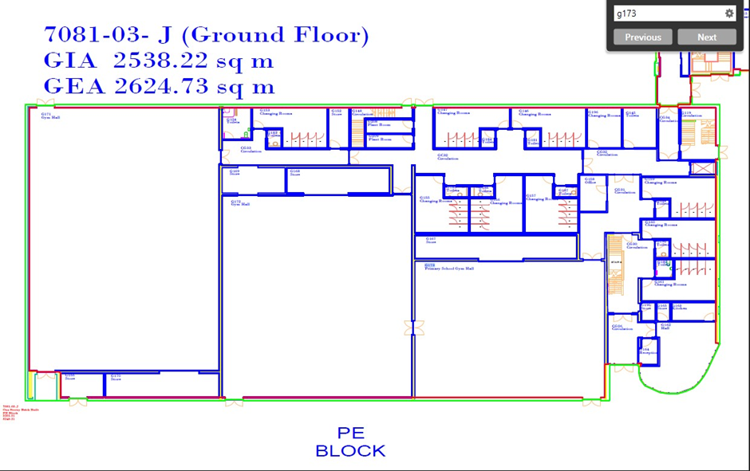
Site Layout Plan
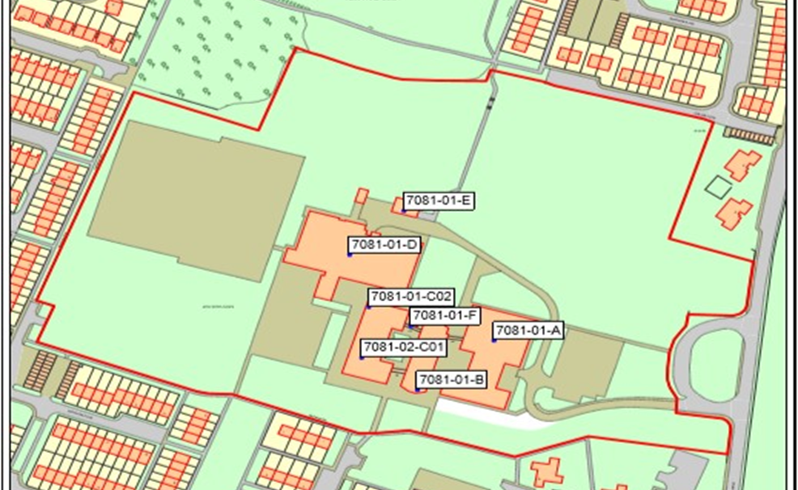

Appendix 2 – Risk Assessments

Documents available upon request
1. SSPBC Risk Assessment 2025
2. Fire Safety Egress Calculations William McIlvanney Campus
3. Evacuate Plan SSPBC
4. Medial Operational Plan

Signed:
Lindsay MacKenzie

Lindsay MacKenzie
CEO SSPDT

